**Objective:**

* This automation is used to involves automating the process of adding/deleting the multiple hosts to an inventory and organizing them into appropriate groups.
* This automation will help to reduce the manual intervention of adding n number of managed nodes in the Ansible automation platform.
* As well as we can consider as one of the dynamic methods of maintain the managed nodes and group for the templates.
* This Playbook allows to interaction with AWX and Ansible Automation controller API for create the

bulk host and Group creation in the any inventory.

**Basic Flow Diagram of host/group creation and deletion:**

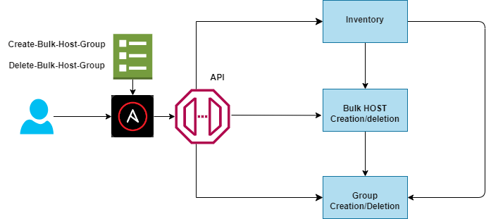

**REQUIREMENTS**

* The AWX.AWX collections MUST be installed for this collection to work. It is recommended they be invoked in the playbook in the following way.

---

- name: Playbook to configure ansible controller post installation

hosts: localhost

vars:

controller_validate_certs: false

collections:

- awx.awx

**Installing this collection**

* You can install the awx.awx collection with the Ansible Galaxy CLI:
* **#ansible-galaxy collection installs awx.awx**
* You can also include it in a `requirements.yml` file and install it with `ansible-galaxy collection install -r requirements.yml`, using the format:
* If you need a specific version of the collection, you can specify like this: #version: 2.xx

---

collections:

- name: awx.awx

#

# version: 2.xxx

**Using this collection**

* The awx.awx collection must be invoked in the playbook for ansible to pick up the correct modules to use inside
* The following command will invoke the playbook with the awx collection.

#ansible-playbook **/playbook/create-host-group-AAP.yml --**extra-vars "@variable.yml"

#ansible-playbook **/playbook/delete-host-group-AAP.yml** --extra-vars "@variable.yml"

**Define following vars inside in the group_vars/all/vars.yml file.**

---

controller_validate_certs: false.

controller_username: "<username to login to the Ansible automation platform>"

#**ansible-vault encrypt_string "<password string to encrypt" --name '<string name of the variable>'**

controller_password: <Encrypted password>

controller_hostname: "<Ansible automation platform hostname>"

**Below are ROLES created for this Automation:**

1. bulk-host-creation.
2. group-creation.
3. Host-deletion.
4. Group-deletion.

**Below is the Extra variable input for Create-host-group-AAP playbook:**

---

controller_inventory_name: "<Name of the inventory>"

controller_host_device_name: " <name of the devices>"

controller_groups_name:

- group_name: "<group name>"

preserve_existing_hosts: "<Default this value is **'false'** if you would like to preserve the existing hosts ‘**True’**>”

hosts: " <name of the devices by comma separated>"

**## Example for bulk host and group creation**

---

controller_inventory_name: "Demo_Inventory"

controller_host_device_name: "switch_name_1,switch_name_2,switch_name_3, switch_name_4"

controller_groups_name:

- group_name: "agv_access"

hosts: "switch_name_1,switch_name_2"

- group_name: "refer_av"

hosts: "switch_name_3,switch_name_4"

**## Example for create only Bulk Host creation**

---

controller_inventory_name: "Demo_Inventory"

controller_host_device_name: "switch_name_1, switch_name_2"

controller_groups_name: []

---

controller_inventory_name: "Demo_Inventory"

controller_host_device_name: "switch_name_1,switch_name_2"

controller_groups_name:

- group_name: "agv_access"

hosts: "switch_name_1,switch_name_2"

**### Below is the Extra variable input for Delete-host-group-AAP playbook**

**---**

controller_inventory_name: "<Name of the inventory>"

controller_host_device_name: "<Name of the device>"

controller_groups_name: "<Name of the group>"

**##Example:**

**---**

controller_inventory_name: "Demo inventory"

controller_host_device_name: "switch_name_1,switch_name_2,switch_name_3"

controller_groups_name: "group_name_1,group_name_2"

controller_state: "absent"